Cheat Sheet: Plotting with Matplotlib
Plotting with Matplotlib using Pandas
Line Plot
Shows trends and changes over time
Pandas Function:
DataFrame.plot.line()DataFrame.plot(kind = ‘line’)
Example:
df.plot(x=’year’, y=’sales’, kind=’line’)
Visual:
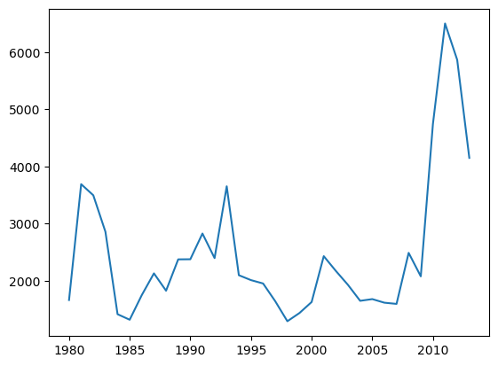
Area Plot
Displays data series as filled areas, showing the relationship between them
Pandas Function:
DataFrame.plot.area() DataFrame.plot(kind = 'area')
Example:
df.plot(kind='area')
Visual:
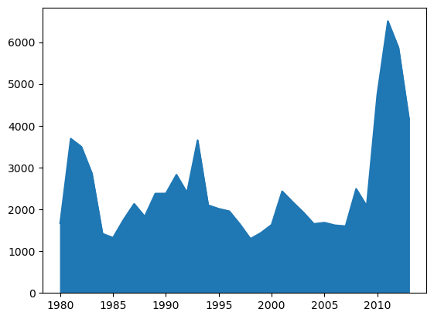
Histogram
Displays bars representing the data count in each interval/bin
Pandas Function:
Series.plot.hist() Series.plot(kind = 'hist', bins = n)
Example:
s.plot(kind='hist', bins=10) df['age'].plot(kind='hist', bins=10)
Visual:
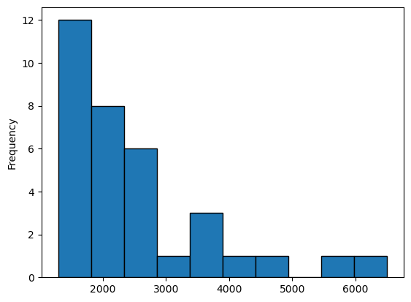
Bar Chart
Displays data using rectangular bars
Pandas Function:
DataFrame.plot.bar() DataFrame.plot(kind = 'bar')
Example:
df.plot(kind='bar')
Visual:
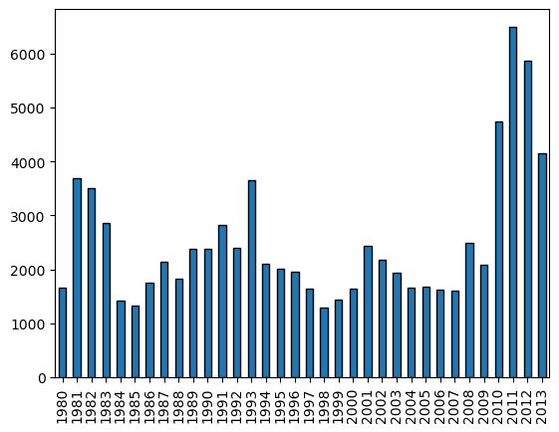
Pie Chart
Displays data as a circular plot divided into slices, representing proportions or percentages of a whole
Pandas Function:
Series.plot.pie() Series.plot(kind = 'pie') DataFrame.plot.pie(y, labels) DataFrame.plot(kind = 'pie')
Example:
s.plot(kind='pie', autopct='%1.1f%%') df.plot(x='Category', y='Percentage', kind='pie')
Visual:
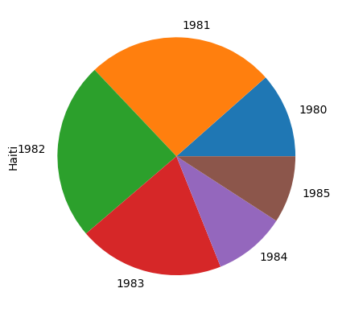
Box Plot
Displays the distribution of a dataset along with key statistical measures
Pandas Function:
DataFrame.plot.box() DataFrame.plot(kind = 'box')
Example:
df_can.plot(kind='box')
Visual:
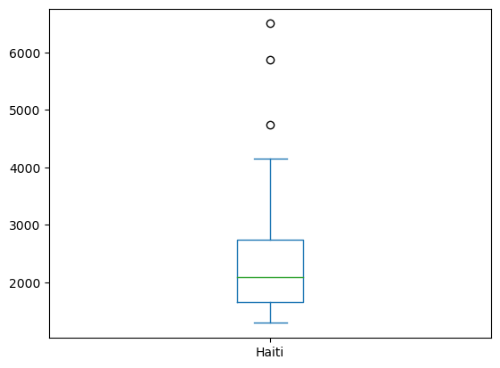
Scatter Plot
Uses Cartesian coordinates to display values for two variables
Pandas Function:
DataFrame.plot.scatter() DataFrame.plot(x, y, kind = 'scatter')
Example:
df.plot(x='Height', y='Weight', kind='scatter')
Visual:
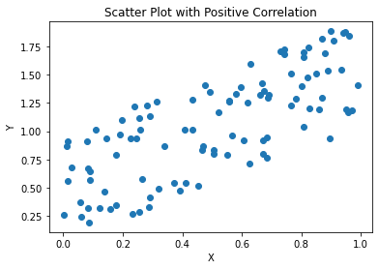
Plotting directly with Matplotlib
Line Plot
Shows trends and changes over time
Matplotlib Function:
plt.plot()
Example:
plt.plot(x, y, color='red', linewidth=2)
Visual:
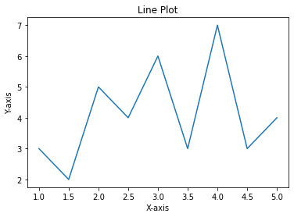
Area Plot
Display data series as filled areas
Matplotlib Function:
plt.fill_between()
Example:
plt.fill_between(x, y1, y2, color='blue', alpha=0.5)
Visual:

Histogram
Displays bars representing the data count in each interval/bin
Matplotlib Function:
plt.hist()
Example:
plt.hist(data, bins=10, color='orange', edgecolor='black')
Visual:
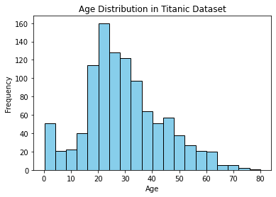
Bar Chart
Displays data using rectangular bars
Matplotlib Function:
plt.bar()
Example:
plt.bar(x, height, color='green', width=0.5)
Visual:
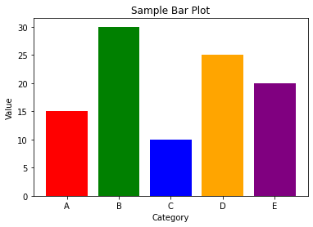
Pie Chart
Displays data as a circular plot divided into slices, representing proportions or percentages of a whole
Matplotlib Function:
plt.pie()
Example:
plt.pie(sizes, labels=labels, colors=colors, explode=explode)
Visual:

Box Plot
Displays the distribution of a dataset along with key statistical measures
Matplotlib Function:
plt.boxplot()
Example:
plt.boxplot(data, notch=True)
Visual:
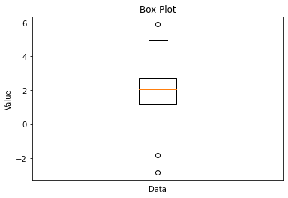
Scatter Plot
Uses Cartesian coordinates to display values for two variables
Matplotlib Function:
plt.scatter()
Example:
plt.scatter(x, y, color='purple', marker='o', s=50)
Visual:
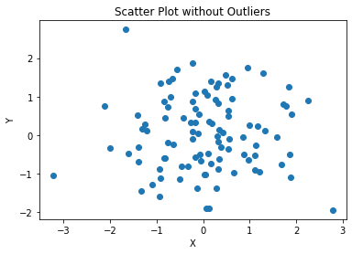
Subplotting
Creating multiple plots on one figure
Matplotlib Function:
plt.subplots()
Example:
fig, axes = plt.subplots(nrows=2, ncols=2)
Visual:
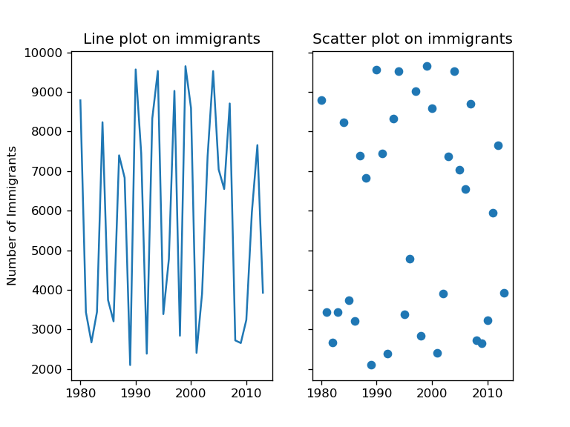
Customization
Customizing plot, including adding labels, title, legend, grid
Matplotlib Function: Various customization
Example:
plt.title('Title') plt.xlabel('X Label') plt.ylabel('Y Label') plt.legend() plt.grid(True)
Visual:
